What is Marketing?

What is Sports?

What is Entertainment?

What is Sports & Entertainment Marketing?

What is a Market?

What is a Target Market?

Who is LEHI HIGH ATHLETICS Target Market?

Who are PRODUCERS? Who are Lehi High’s PRODUCERS?

Who are CONSUMERS? Who are Lehi High’s CONSUMERS?
Define Product. What is Lehi High’s PRODUCT?

What is an EXCHANGE?

What is THE MARKETING CONCEPT?

Explain each of the 4 P’s. Give an example WITHIN Sports & Entertainment Marketing - more specifically LEHI HIGH SCHOOL
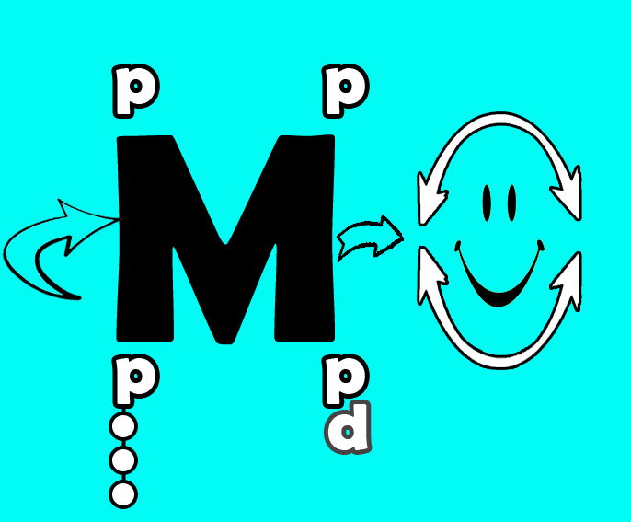

P_____________________

1.

P_____________________

1.

P_____________________

1.

P_____________________

1.

Explain the difference of Marketing OF Sports and Marketing THROUGH Sports.

Who are the players in the Marketing OF Sports? For LEHI HIGH SCHOOL?

What are some examples of Marketing THROUGH Sports? Who utilizes LEHI HIGH SCHOOL to market?

Name ________________________________________ Class Period _________________

Unit 1 - Student Assignment

What is Sports & Entertainment Marketing (SEM)?

Copyright © 2007 by Sports Career Consulting, LLC
Sports & Entertainment Marketing Education

Assignment Directions:

For the next class period, bring in two examples of sports and entertainment marketing that you have come across. It can be printed from the Internet, something from a newspaper or magazine, or even a description of something you saw on television or heard on the radio.

Be prepared to discuss/answer the following questions:

1) What is the product or service being marketed?

2) Who is the product or service being marketed to?

3) Do you think sports/entertainment provides an effective platform for this company to market its product or service? Why or why not?

4) Explain why this is an example of sports/entertainment marketing.

