Promotion
A marketing function needed to :

3 Main goals of Promotion

Used together the hope will be that these goals:

Promotional Mix

Personal Selling

Advertising

Do you think advertising works? Why or why not?

Did advertising work in the case of DeBeer/Diamonds? Why or why not?

Sales Promotion

Tell me about the Selena Contest/Giveaway…. Do you think it was effective?

Public Relations

What is Public Relations designed to do?

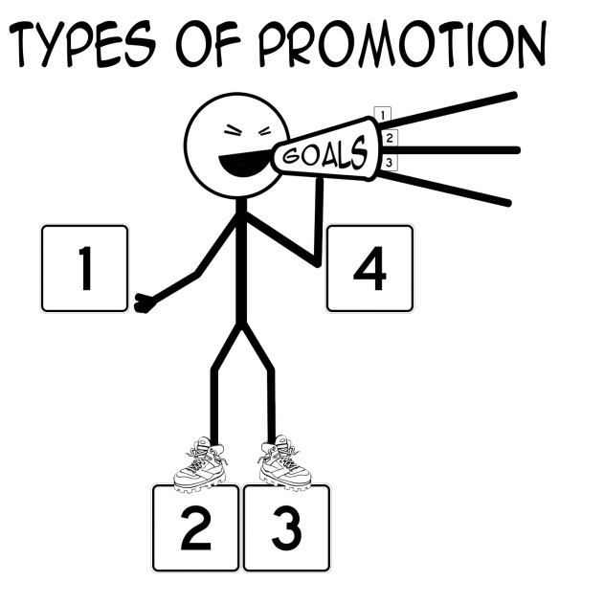
Fill in the “Promotion Man”. Be sure to label the cost of each promotion

List the steps to using the promotional mix.
1. | 3.
2. | 4.

Businesses Selected A) _____________________________ B) _____________________________
Look on the internet and find one examples of each of the promotional mix that two competing businesses are using to influence purchasing decisions. Details and specifics! After analyze who you feel is doing the better job.

PERSONAL SELLING:

a)
b)

ADVERTISING:

a)
b)

SALES PROMOTION:

a)
b)
PUBLIC RELATIONS:

a)
b)
WHO DO YOU FEEL IS DOING THE BETTER JOB? WHICH BUSINESS HAS CONVINCED YOU MORE? WHY?

***Examples:
Personal Selling: Cashiers, Drive through cashiers, Internet Customer Service help
Advertising: Billboards, TV, Facebook, Mobile Ads, Bus benches
Sales Promotion: Coupons, Limited time sales, games, BOGO, Contests
Public Relations: News Releases, Secret menu items, TV talk show

