10/19/2013
Mr. Assmus
Time line of October 25th

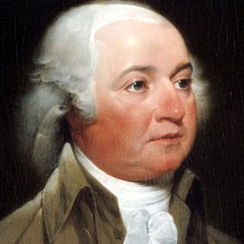
1764- John Adams Marries Abbigal Adams
The 2nd President of the USA marries a great woman who was never hesitant to share her views on politics with the world. Their marriage becomes an example of what every First Lady and President Marriage should be like.

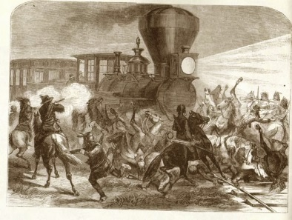
1853- Indians Attack Transcontinental Railroad survey crew in Utah
Piute Indians attacked 37 soldiers and railroad workers working on the railroad. Seven workers were killed. It lead to a better route through the mountains and finishing the transcontinental route.
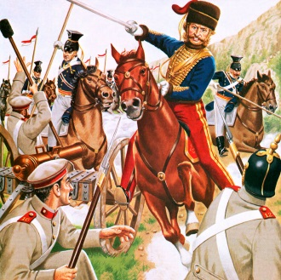
1854- Charge of the Light Brigade
Lord Cardigan accidentally leads his troops straight into the Russian Army and loses 40% of his men. Cardigan, survived and was later named a National Hero in England.

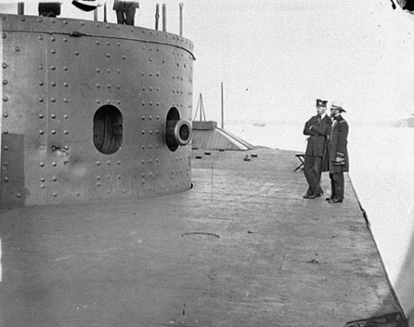
1861-The USS Monitor is Laid
The Iron clad from the Civil War is laid to rest in the harbor in New York. It was part of one of the most infamous war battles in the Civil War against the Southern Iron Clad the “Virginia.” The battle ended in a draw.

1944—Japanese Troops employ first Kamikaze attacks
Suicide bombers are first implemented in Japanese war tactics. It proves costly and deadly for both sides.

1981—Mr. Assmus, I mean, MR. AWESOM IS BORN
What more needs to be said then this?

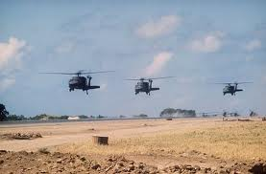
1983—United States invades Grenada
Ronald Regan, fearful of Marxsist and Comunist threats, ordered an attack on Grenada to overthrow the government of the Caribbean island nation. The US was successful.

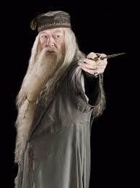
2002—Dumbledore from Harry Potter Dies
Richard Harris, who starred in dozens of movies and was a Rugby player, died on this day. His legend will never die in millions of Potter fans’ hearts.

People Born on my Birthday

BOBBY KNIGHT PABLO PICASSO

