Memo Assignment

Memo Info:

Memo’s are professional letters that are sent inside of a company. We made Personal Block Letters last time—those are letters that you send to an outside company. Memo’s are company wide letters. For example, if you work at Nike, you would send a Memo to the people that work in your department that work at Nike.

Memo Assignment:

Today you are going to pretend you are the Activities Director at a company. You are manager over 4 people and will be writing a Memo to four (4) people in your company. The four people can be anyone you choose. Lafawnda, Shaniqua, Bob and George for example. You are going to be fulfilling a wish for a person (You can chose whatever person you want for their dream) The Memo is going to include instructions to your co-workers on what their dream entails and what they need to do to fulfill the dream.

- Choose a company to work for that someone would want to visit or do. For example, you probably wouldn’t have a kid choose to go to McDonalds for their Dream Wish.
- Begin with the End in Mind. Sky’s the limit for this dream. For example, if a girl had a wish to meet all of the Princesses at Disneyland, start with that, and figure out what you would need to do start to finish to make sure your kid gets everything they want.
- Include four co-workers in the “To” section
- CC me (Mrs. Judson)
- Subject line: Make-A-Wish
- Watch the video on my website so you can see an example of a Wish that came true
- Visit www.wish.org for an example of other Wishes that kids have had in the past. (Don’t spend more than 10 minutes on this site, you need to type your letter)
- Type 4 Paragraphs of at least 4 sentences each to tell your co-workers what to do/what to expect with this Wish.
- Drop it to me
- Follow the directions below to get a Template of a Memo from Word

How to get a Memo Template:
- In Word go to the “File Tab”
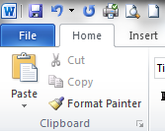

- Click on “New” and click on the “Memo” Button

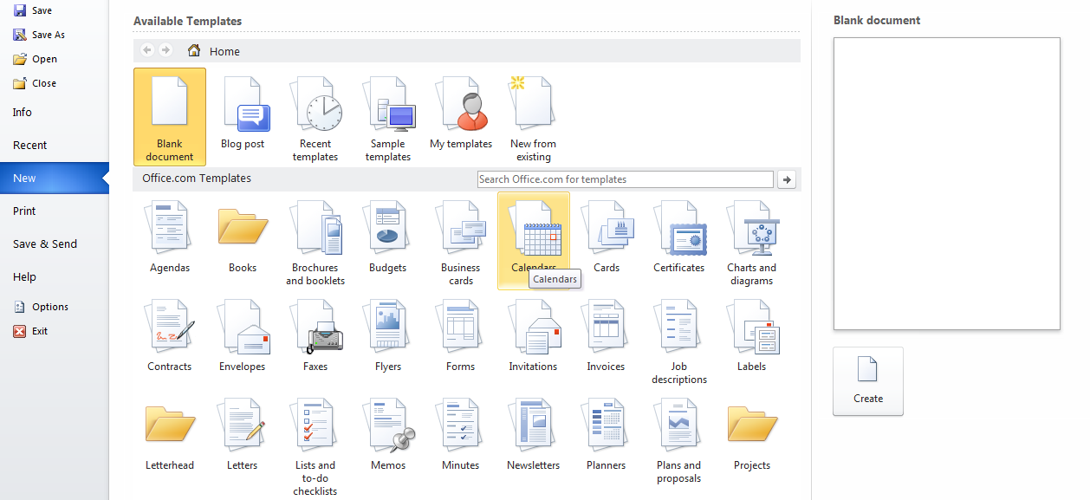

- Chose the first Memo that is on the screen called “Memo Contemporary Design” and then hit “Download” on the right side of the page
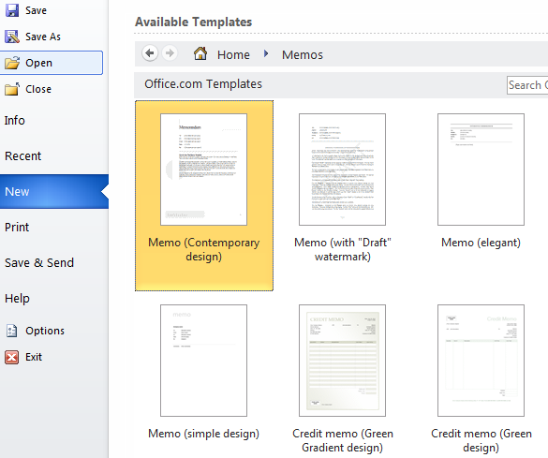

- There are a few parts of a Memo that you need to fill out. (See Below)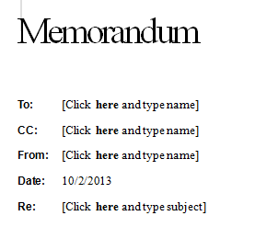
Make-A-Wish
It will put in today’s date
Your name goes here
CC: Just like in an e-mail—Put in my name
The 4 people you are writing the memo to

- Start to type your letter. Remember it needs to be 4 paragraphs of at least 4 sentences in each paragraph. Please do a good job on this. Take it seriously.

