How to create a Works Cited and In-Text Citations

You will be using the “REFERENCES” tab a lot for this section. The following is random text.
Here is an example:

Step 1: Write your text. Include facts.
On the Insert tab, the galleries include items that are designed to coordinate with the overall look of your document. You can use these galleries to insert tables, headers, footers, lists, cover pages, and other document building blocks. When you create pictures, charts, or diagrams, they also coordinate with your current document look. You can easily change the formatting of selected text in the document text by choosing a look for the selected text from the Quick Styles gallery on the Home tab. You can also format text directly by using the other controls on the Home tab.
The orange text is text that is fact and needs to be cited or credited by its owner.

Step 2: Give Credit to the owner of the quote, statement or fact.
On the Insert tab, the galleries include items that are designed to coordinate with the overall look of your document. You can use these galleries to insert tables, headers, footers, lists, cover pages, and other document building blocks (Krueger). When you create pictures, charts, or diagrams, they also coordinate with your current document look. You can easily change the formatting of selected (Da Bulls) text in the document text by choosing a look for the selected text from the Quick Styles gallery on the Home tab. You can also format text directly by using the other controls on the Home tab (Awesome).
At the end of the sentence and before the period enter in a space and then click on the “REFERENCES” TAB and click “INSERT CITATION”

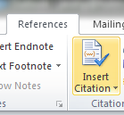
- Then choose your Type of Source.
- Put the Authors name in, Last Name, First. If it’s a Corporate Author, Click on the Button.
- Type in the Web Page Name & other information that you can find.
- Click OK

Step 3: Continue to do this to every spot you need to cite (NOT EVERY LINE WILL HAVE A CITATION)

Step 4: Make a “WORKS CITED” PAGE
After you are done citing (you should have at least 3 references) you need to make a Works Cited Page. This will be the last thing that you do. Word will keep track of all of your citations (references) for you, as long as you enter them in correctly.

How to do it:
- Go to the last line of your typed text (CTRL + END)
- Insert a Manual Page Break
- Click on the References Tab

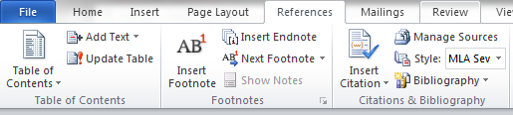

- Make sure your style is MLA Seventh
- Click on the Arrow to the Right of Bibliography
- Choose the Works Cited Option

- You’re all set. Word will make it in Alphabetical Order, and format it correctly for you.
- Tell your teacher that you are very appreciative that you don’t have to alphabetize it and key in everything like we had to do when we were your age.

Works Cited
Awesome, Mr. Why Are You So Cool? Braden Smith. 25 October 2013.
Da Bulls. "I have 6 Rings." Jordan, Michael. We are the champions. Chicago: Dynasty, 1999. 100-103.
Krueger, Freddy. Nightmare on Elm Street. 25 October 2012.

