Name: _________________________________ Period: ________ Score: ____/20

Computer Basics
Hardware

Central Processing Unit (CPU)
RAM
ROM
Motherboard
Hard Disk Drive

Hertz

Peripheral Device

Input Device
Output Device

Place the following in order from smallest to largest:

_____ Gigabyte

_____ Byte

_____ Kilobyte

_____ Megabyte

_____ Bit

____ Terabyte

How are you going to remember it?

Label the following device AND if it’s an INPUT or OUTPUT device.
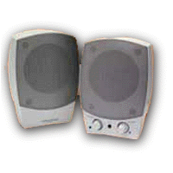
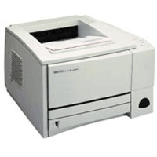
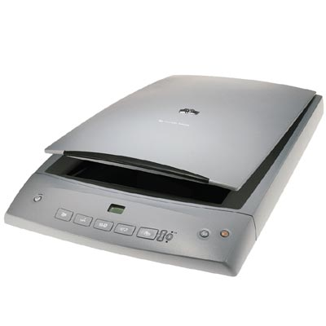

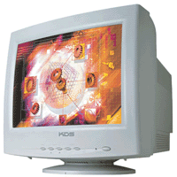
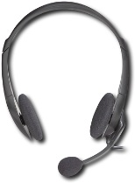
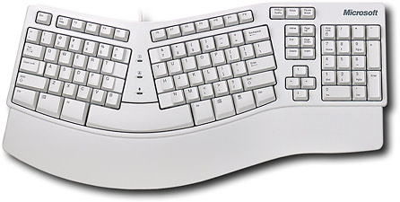

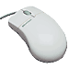

Answer the following questions:

- Short term memory is also known as ____________________.

- The more ____________________ that your computer has, the faster it processes data.

- The ____________________ is the #1 input device.

- The ___________________________________ is the brain of the computer.

- The ___________________________________ is the heart of the computer.

- CPU stands for __________________________________________________.

- Write 3 examples of a storage device:

- What is a peripheral device? __________________________________________

  - Write an example: ____________________________________________

- What is the smallest measure of memory? _______________________________

- What is the largest measure of memory? ________________________________

- _______________ measures the processing speed of the CPU.

