Name: ____________________________________________________ Period: ____________________

Viruses
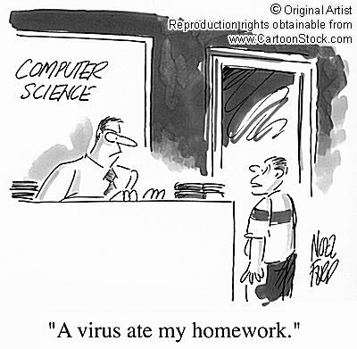
Virus:

Worm:

Email Virus:

Trojan Horse:

Boot Sector Virus:

Time Bomb:

Logic Bomb:

- What are 3 things you can do to protect your computer from a Virus?

Computer Ethics

In this assignment, you will become acquainted with ethics, rules, and laws as related to computers and information resources.

GETTING READY . . .
        - Think about ethics that govern your own choices in life situations.
        - Think about rules that you follow when you use a computer.
        - Think about risks you (or other people) have taken by misusing a computer system and resources.
          - Did you know your actions were wrong but you carried them out anyway?
          - Or, are you completely surprised to learn that your actions were wrong?
      - Resolve to become an ethical computer user who follows rules and respects laws in every situation.
- Open the ethics_powerpoint found on the classroom website.

Play the slide show by hitting the f5 button. Click through the various slides and links to find the information needed to answer the following questions:

A. What are ethics?
1. | 2. | 3.

B. What are ethics not?
1. | 2. | 3.

C. Where do ethics come from?
1. | 2. | 3. | 4.

D. An Ethical Person

E. What might follow an unethical choice?
1. | 2. | 3. | 4. And what other ideas do you have?

F. What are rules?

G. What happens if rules are violated?

ACCEPTABLE USE POLICY – A policy set up to tell you what you can and cannot do with a computer.

Please locate the Alpine School District AUP for students. (A link on slide 8 will take you there. It says “This way to AUP” then click on the underlined AUP Link)

H. Read all 10 Prohibited Uses (Things students will not do) of the District’s computers and network. Choose 8 and summarize (one or two words to describe it) in the cells below.

1. | 2. | 3. | 4.
5. | 6. | 7. | 8.

Return to the PowerPoint Slide Show by closing out of the
Acceptable Use Policy

I. What are Laws? (Slide 9)

J. What might happen if you are convicted of breaking the law?

____________________________________________________________________________________

K. Write notes about each type of law in the table below.

These different types of laws exist to provide protection and punishment | NOTES ABOUT LAWS  In this column, write some details that are important for each type of law.
COPYRIGHT LAWS
PUBCIC DOMAIN
LICENSE
FREEWARE LICENSE
SHAREWARE LICENSE
ALL RIGHTS RESERVED LICENSE

