**File Management**

Is working on 2 or more open programs

Steps:

1.

2.

**Save / Save As**

Save:

Save As:

**Copy:**

**Move:**

**How to Delete a file/folder:**

**How to Rename a Folder:**

1.

2.

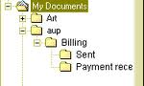

**Folders and Sub Folders**